

**Year 5 & 6 Cricket**

**catching challenges**

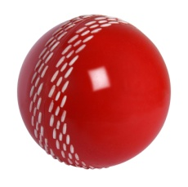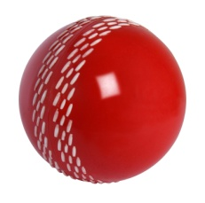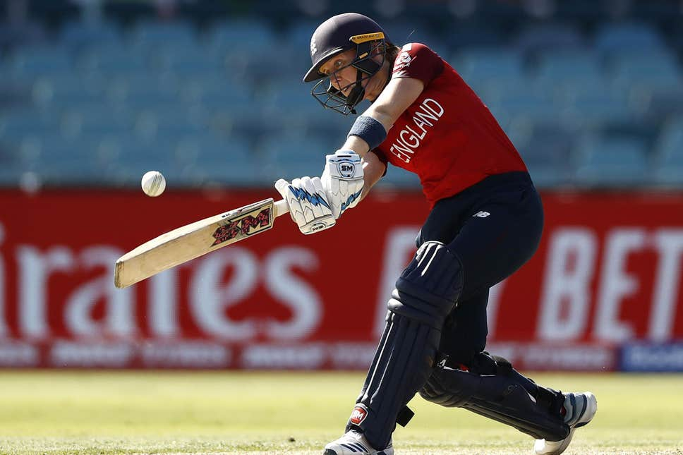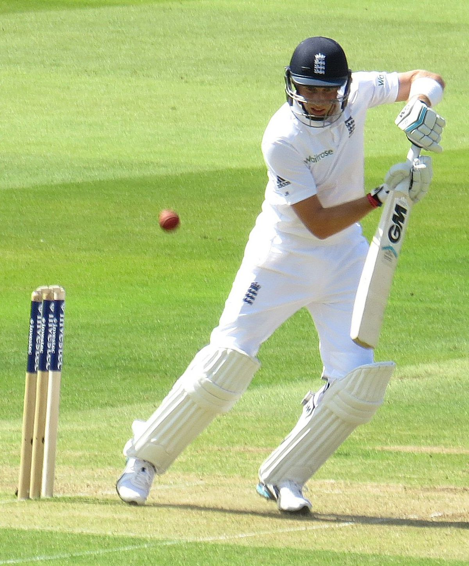

EQUIPMENT NEEDED BEFORE YOU START- one ball (cricket ball or tennis ball size)

Complete each challenge for 20 seconds- how many can you do? Record on the results sheet

**7.**

**6**

**5**

**4**

**3**

**1**

**2**

*Can you do these skills as well as Heather Knight and Joe Root?*

Can you catch with one hand?

Bounce the ball on the floor three times and catch it.

Throw the ball up in the air, spin all the way round, let the ball bounce once and catch it.

Throw the ball under one leg, up in the air and catch it.

Throw the ball up in the air, clap once and catch it.

Throw the ball up in the air, spin all the way round and catch it (without a bounce).

Throw the ball up in the air and catch it, without a bounce.

Throw the ball up in the air, let it bounce once and catch it.

Try a different size ball!

Joe Root – England Men’s Test Cricket Captain

Heather Knight – England Women’s Cricket Captain