June and July 2020 Year 2 Mini Games

The main aim of this event is to have fun and for the children to do their best. They can have up to 3 attempts at each of the 10 ‘stations’ with only their best score being recorded on the results sheet. Please watch the video clips that accompany this information sheet for further clarity of each station.
Please also ensure the ground is flat and there are no breakable objects nearby or obstacles which can be tripped over.
EQUIPMENT YOU WILL NEED BEFORE YOU GET STARTED:
- A stopwatch
- 7 markers- these can be rolled up tea towels or rolled up t-shirts, or skipping ropes (shown below with a red rectangle). You can also use chalk to create markers if you’re using a patio
- 3 adult t-shirts
- 1 bucket or small bin (shown below in black)
- 3 pairs of ADULT socks rolled up to create a ball shape (shown below as blue balls)
- The results sheet
- 3 plastic cups (shown below in blue)
- 6 empty loo roll tubes (shown below as a brown tube)
- 2 new loo rolls (shown below as a white tube)
- 1 skipping rope

- Throw to target
Equipment needed: 1 marker, 3 pairs of socks
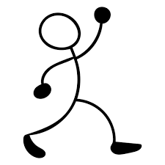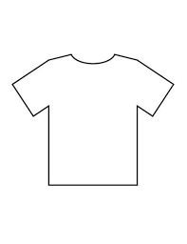
Children throw the 3 pairs of rolled up socks one at a time in the direction of the t-shirts using an over arm action if they can.
- Maximum points for this station is 9 if all 3 socks land on the furthest t-shirt every time
2m 1m/1point 2m/2 points 3m/3points
- 20m sprint
Set up the station allowing for 2m either side of the markers (in case of falling over or the need to slow down)
Children need to step over the markers before turning or the watch stopped
If a 10m stretch is not possible, then reduce it to 5m and run 4 times
- Quickest time is recorded
Equipment needed: 2 markers, stopwatch

10m

- Dribble
Equipment needed: 1 marker, 1 bucket or bin, 3 pairs of rolled up socks, stopwatch
Children walk/jog/run from the marker to the bucket 3 times as quickly as they can- If they drop the socks they just pick them up and carry on
1st time they balance one pair of rolled up socks in the palm of their hand, drop the socks into the bucket and run back to the marker.
2nd time balance one pair of rolled up socks on their head, drop the socks into the bucket and run back to the marker.
3rd time they use both feet to dribble the rolled up socks along the floor towards the bucket, once there they can use their hands to pick them up and drop into the bucket before running back to the marker
- Quickest time for all 3 is recorded

5m

- Skipping
Equipment needed: 1 skipping rope, stopwatch
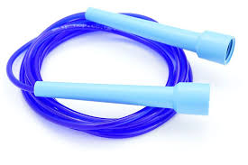
Children skip on the spot using whichever landing they like.
- How many they do in 20seconds is recorded
- Throw for distance
Equipment needed: 3 pairs of rolled up socks, 4 markers
Children throw the rolled up socks one at a time and adults see where it first touches the floor and tell them how many points they have scored.
- Maximum points for this station is 15 (3 lots of 5 points)

3m/1point 2m/2points 2m/3points 5points

- ‘Ladder’ sprints
Equipment needed: 7 markers, stopwatch
Children need to walk/jog/run up to then ‘though the ladder’ and then over the furthest marker before running in a straight line at the side on the way back
- Quickest time is recorded

3m 20cm intervals 3m
- Standing long jump
Jumping from 2 feet to 2 feet children stand behind the first marker and see how far forward they can jump. Repeat twice more.
They can bend their knees and swing their arms to help them
- Maximum points scored is 9 (3 lots of 3points)
Equipment needed: 4 markers

50cm/1point 50cm/2points 50cm/3points

- Speed bounce
Equipment needed: 2 new loo rolls, stopwatch
Place the 2 loo rolls next to each other to create a line. Children stand to the right of the 2 loo rolls. They then jump off two feet over the loo rolls and land on two feet on the other side. Over is 1, back is 2 and so on
- How many times can they jump over the loo roll in 20seconds is recorded

- Cup stack pyramid
Children run up to the plastic cups, stack them into a pyramid, then runs back to the marker.
Then runs back to the cups and unstacks them, then runs back to the marker.
- How many times can the cups be stacked up AND taken down in 30seconds is recorded
Equipment needed: 3 plastic cups, stopwatch, 1 marker

5m
- Loo roll skittles
Equipment needed: 6 empty loo rolls, 3 pairs of rolled up socks
Children have to get as many tubes knocked down by throwing their 3 pairs of rolled up socks one at a time
If all 6 get knocked down with the 1st or 2nd ball, they can be stood back up again ready for the 3rd ball
- Maximum number knocked down with the 3 balls is recorded

3m 30cm
Please send your results through to jbuckley@wdf.school by 8th July so that all results can be collated and winners notified (via your school) before the end of term. THANK YOU for taking part in the Yr 2 William de Ferrers School Sports Partnership first ever virtual Mini Games
And then once you have finished with the toilet rolls, you can create some fantastic craft…… here are a few ideas off the internet:
