Yr 3/4 PE
SCAVENGER HUNT!

- You will need: a piece of paper and pen
- Write the alphabet down the left hand side
- A box or a table to put your hunted pieces into!
- Search your house or garden to find something that begins with A and bring back to the box/table
- Do the same for B, C and so on
- If you cant think/find an item for a letter, don’t worry, move onto the next letter. Try and get half of the alphabet

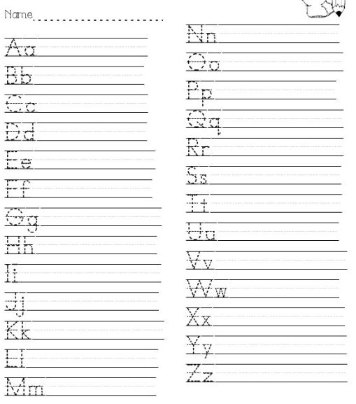
Further ideas
Here are a list of recommended links of videos which can be followed (all are free of charge);

Active Essex
Keep Essex Active YouTube Channel: https://www.activeessex.org/keep-essex-active-youtube/
A Monday to Sunday timetable of ‘classes’ live on their You Tube Channel covering 4 areas- Gentle exercise, High impact, Health and wellbeing and Active families.
Keep Essex Active from Home: https://www.activeessex.org/keep-essex-active/

Youth Sport Trust #StayHomeStaySafe
www.youthsportstrust.org/free-home-learning-resource-primary
Primary and Early years sections. Early years there are 4 resources. Primary there are 3 resource areas- 1) PE home learning (athletics, dance, games, gymnastics, health related exercise, inclusion, locomotion, outdoor and adventure) 2) 60 second challenges (x20 challenges) 3) Active learning- how to include English and Maths in physical activities

Sport England- Stay in work out initiative- Get active at home, Get active outdoors tabs for further links
https://www.sportengland.org/stayinworkout

Change4life Activities for Children
https://www.nhs.uk/change4life

Chance to Shine cricket
https://www.chancetoshine.org/staying-active-during-the-covid-19-outbreak?utm_source=Portal+Teachers&utm_campaign=5811d5dc45-EMAIL_CAMPAIGN_2020_04_24_03_37&utm_medium=email&utm_term=0_b4486fc5f7-5811d5dc45-138455733

Cosmic Kids Yoga – Youtube- Yoga and Mindfulness is the focus
https://www.youtube.com/results?search_query=cosmic+yoga+

Joe Wicks Kids Workouts – Youtube
HIIT (High Intensity Interval Training) sessions for children (5min videos can be done in a small space), Kids Workout – The Body Coach TV. Every morning at 9am the body coach will be hosting a live workout session for children on his YouTube Channel
https://www.youtube.com/results?search_query=joe+wicks+kids+workout

Imoves Activities https://imoves.com/

Go Noodle www.gonoodle.com Free to sign up for families and educators

BBC SuperMovers https://www.bbc.co.uk/teach/supermovers/super-movers-day/zbmnnrd

Cosmic Kids Yoga – Youtube https://www.youtube.com/results?search_query=cosmic+yoga+

Healthy Futures – http://eepurl.com/gVYzoD
You will receive a weekly food and activity log plus daily exercise videos to keep your children active! You just need to sign up as a parent
Sporting Challenges: NEW Everyday we will be uploading a daily sporting challenge that can be completed at home, we encourage everyone to get involved on the hashtag #HFhome

@GetSet4PE will be tweeting an active task each day that schools are closed

Imovement : To sign up, all you need to do is use the link join.theimovement.com its free to join just click on the link or follow on twitter @imovesactive The imovement is separate to their paid for imoves and will be 100% free.

