KS2 PE
MENU OF ACTIVITIES
- Pick one starter, one main and one desert each day to complete
- Can you try each dish on the menu by the end of the week?
- What is your favourite starter, main course and desert?
- Remember keep within the Government guidelines: keep active and stay safe!

Starters
Joe wicks daily workout 9am on YouTube
Exercise challenges from the Healthy Futures Active Monopoly (see page 2): Do one brown, one red and one dark blue
Cosmic kids on You tube- you choose which one
Main Course
Active Monopoly- Active Monopoly- Do one activity from each side of the board (not the same as you may of done for your starter!)
#stayActive on twitter –Adam Rowland – goal keeping/Alex Goldman 1st challenge
Youtube live #Gymnastics with Max Whitlock Tuesday/Fridays 3-30pm
Go for a jog with your dog or ride your bike while your parents jog!
Desert
Play hop scotch
Go out daily for a walk and try and hold a conversation throughout without getting out of breath
Skip for 20 seconds then 30 seconds rest x 3

ACTIVE MONOPOLY CHALLENGES
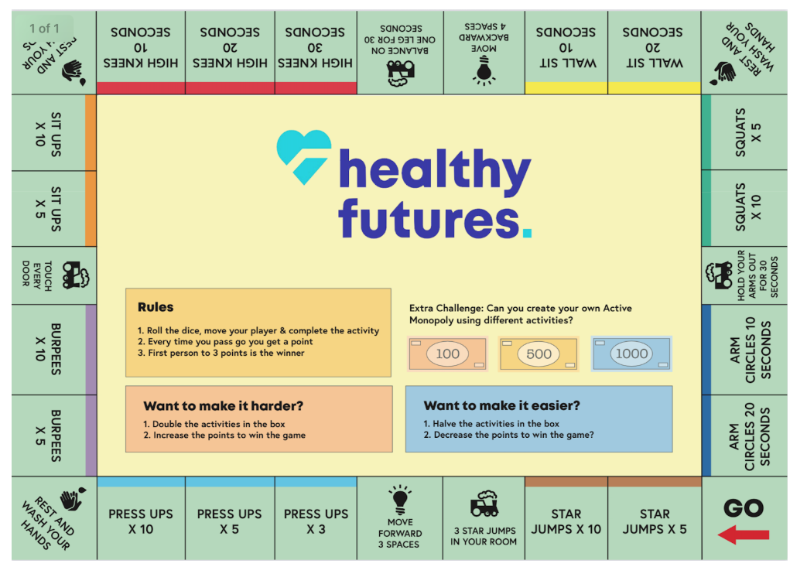

Just for fun!!!
Make a snake, butterfly or owl using one of your empty toilet rolls- https://www.persil.com/uk/sustainability/sustainability-for-kids/recycling-crafts-for-kids-toilet-roll-crafts.html

Toilet Roll Snake
This is the easiest out of our three toilet roll craft ideas. You'll need: one toilet roll, two small googly eyes, paint, glue, felt tip pens, red paper, and scissors.

Instructions:
- Paint the outside of the toilet roll and then let it dry.
- Use the scissors to cut a spiral strip from the toilet roll, shaping one end of the strip like a tail, and the other like a snake's head.
- Glue on the googly eyes.
- Cut a red forked tongue from the paper and glue it on to the head of the snake.
- Finish the snake by adding designs along the length with the felt tip pens.

Toilet Roll Butterfly
This is one of the great classics when it comes to making crafts from recycled materials. All you'll need is: one toilet roll, a pipe cleaner, two googly eyes, coloured paper, scissors, white glue, a black pen, paint, and a paint brush.
Instructions:
- Paint the toilet roll the colour you'd like the body of your butterfly to be and put it aside to dry.
- Cut wing shapes from the coloured paper – patterned wrapping paper will look great or you can use paint to add your own designs to the wings.
- Use glue to stick the toilet roll in the middle of the wings.
- Glue the eyes to the top of the toilet roll and draw on the rest of the butterfly's face.
- Glue two short pieces of pipe cleaner to the inside of the front of the toilet roll to form the antennae.
- Your butterfly is now complete – and what's more – you can also use it as a finger puppet!

Toilet Roll Owl
These wise looking birds would make great gifts for teachers! Here's how to make another easy craft with waste materials for kids. You'll need: one toilet roll, a selection of coloured paper, white glue, and scissors.
Instructions:
- Cover the toilet roll in coloured paper by spreading glue on the outside of the toilet roll and rolling it in the paper until both ends meet. Hold the paper together with a paperclip until the glue dries.
- Fold the front and the back of the toilet roll into the middle to form the owl's ears.
- Cut a small triangle of paper and fix this to the front of the toilet roll to form the owl's beak.
- Then, cut two coin-sized disks out of white paper and two smaller circles of black paper. Layer them on top of each other and stick them above the beak to form the eyes.
- Finally cut two leaf-shaped pieces of paper and glue these to the sides of the toilet roll to form the wings.
- Optionally, attach a loop of ribbon or wool to the top of the owl, so you can hang it up.

Further ideas
Here are a list of recommended links of videos which can be followed (all are free of charge);

Active Essex
Keep Essex Active YouTube Channel: https://www.activeessex.org/keep-essex-active-youtube/
A Monday to Sunday timetable of ‘classes’ live on their You Tube Channel covering 4 areas- Gentle exercise, High impact, Health and wellbeing and Active families.
Keep Essex Active from Home: https://www.activeessex.org/keep-essex-active/

Youth Sport Trust #StayHomeStaySafe
www.youthsportstrust.org/free-home-learning-resource-primary
Primary and Early years sections. Early years there are 4 resources. Primary there are 3 resource areas- 1) PE home learning (athletics, dance, games, gymnastics, health related exercise, inclusion, locomotion, outdoor and adventure) 2) 60 second challenges (x20 challenges) 3) Active learning- how to include English and Maths in physical activities

Sport England- Stay in work out initiative- Get active at home, Get active outdoors tabs for further links
https://www.sportengland.org/stayinworkout

Change4life Activities for Children
https://www.nhs.uk/change4life

Chance to Shine cricket
https://www.chancetoshine.org/staying-active-during-the-covid-19-outbreak?utm_source=Portal+Teachers&utm_campaign=5811d5dc45-EMAIL_CAMPAIGN_2020_04_24_03_37&utm_medium=email&utm_term=0_b4486fc5f7-5811d5dc45-138455733

Cosmic Kids Yoga – Youtube- Yoga and Mindfulness is the focus
https://www.youtube.com/results?search_query=cosmic+yoga+

Joe Wicks Kids Workouts – Youtube
HIIT (High Intensity Interval Training) sessions for children (5min videos can be done in a small space), Kids Workout – The Body Coach TV. Every morning at 9am the body coach will be hosting a live workout session for children on his YouTube Channel
https://www.youtube.com/results?search_query=joe+wicks+kids+workout

Imoves Activities https://imoves.com/

Go Noodle www.gonoodle.com Free to sign up for families and educators

BBC SuperMovers https://www.bbc.co.uk/teach/supermovers/super-movers-day/zbmnnrd

Cosmic Kids Yoga – Youtube https://www.youtube.com/results?search_query=cosmic+yoga+

Healthy Futures – http://eepurl.com/gVYzoD
You will receive a weekly food and activity log plus daily exercise videos to keep your children active! You just need to sign up as a parent
Sporting Challenges: NEW Everyday we will be uploading a daily sporting challenge that can be completed at home, we encourage everyone to get involved on the hashtag #HFhome

@GetSet4PE will be tweeting an active task each day that schools are closed

Imovement : To sign up, all you need to do is use the link join.theimovement.com its free to join just click on the link or follow on twitter @imovesactive The imovement is separate to their paid for imoves and will be 100% free.

