KS2 PE
MENU OF ACTIVITIES
- Pick one starter, one main and one desert each day to complete
- Can you try each dish on the menu by the end of the week?
- What is your favourite starter, main course and desert?
- Remember keep within the Government guidelines: keep active and stay safe!

Starters
Joe wicks daily workout 9am on YouTube- stop each activity when you get out of breath!
Exercise challenges from the Healthy Futures Active Monopoly (see page 2): Do the lowest numbered brown, red and dark blue
Cosmic kids on You tube- you choose which one
Main Course
Active Monopoly- Active Monopoly- Do the highest numbered brown, red and dark blue (i.e. not the same as you may of done for your starter!)
Andy Wild CBeebies- search on Youtube
Skip around your garden for 5 minutes or if you have a hula hoop then see if you can keep it going for 1 minute around your waist!
Desert
Balance on one foot for 10 seconds, then try the other foot
Go out daily for a walk and try and hold a conversation throughout without getting out of breath
Active Monopoly-Do all 4 of the ‘train stations’

ACTIVE MONOPOLY CHALLENGES
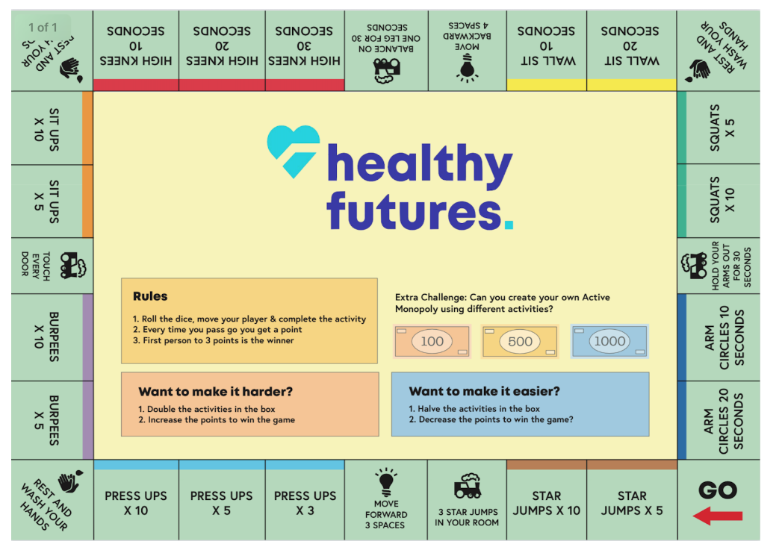

Just for fun!!!
https://www.persil.com/uk/dirt-is-good/arts-crafts/recycling-craft-ideas-activities-kids.html

Plastic Bottle Bird Feeder
The best recycling activities for kids aren’t just fun ways to reuse old items – they also leave you with something special you can use for months to come. Keep the birds happy through winter (and have fun spotting them with your kids!) by making this easy homemade bird feeder that you can hang in your garden or window.

You Will Need:
- An empty water bottle and cap
- A skewer
- 2 coloured pencils (or chopsticks if you’re using a large bottle)
- String
- Scissors
- A bag of birdseed.

How to Make It:
- Remove the label and thoroughly wash the bottle; let it dry.
- Use the skewer to create holes a couple of centimeters above the base of the bottle – you’ll want to do this bit yourself.
- Ask your kids to feed the coloured pencils through the holes to make perches, placing them one above the other in a crisscross position.
- Punch one more hole on each side above the perches as feeding holes.
- Use the string to hang the bottle – cut a length long enough to tie around the neck of the bottle with about 40 cm to spare, and knot it under the lid so that it can’t slip off. Loop the long end of the remaining string over the top and make a matching knot on the other side to form a handle.
- Fill the bottle with birdseed and hang it up.
- Wait for the birds to arrive!

Further ideas
Here are a list of recommended links of videos which can be followed (all are free of charge);

Active Essex
Keep Essex Active YouTube Channel: https://www.activeessex.org/keep-essex-active-youtube/
A Monday to Sunday timetable of ‘classes’ live on their You Tube Channel covering 4 areas- Gentle exercise, High impact, Health and wellbeing and Active families.
Keep Essex Active from Home: https://www.activeessex.org/keep-essex-active/

Youth Sport Trust #StayHomeStaySafe
www.youthsportstrust.org/free-home-learning-resource-primary
Primary and Early years sections. Early years there are 4 resources. Primary there are 3 resource areas- 1) PE home learning (athletics, dance, games, gymnastics, health related exercise, inclusion, locomotion, outdoor and adventure) 2) 60 second challenges (x20 challenges) 3) Active learning- how to include English and Maths in physical activities

Sport England- Stay in work out initiative- Get active at home, Get active outdoors tabs for further links
https://www.sportengland.org/stayinworkout

Change4life Activities for Children
https://www.nhs.uk/change4life

Chance to Shine cricket
https://www.chancetoshine.org/staying-active-during-the-covid-19-outbreak?utm_source=Portal+Teachers&utm_campaign=5811d5dc45-EMAIL_CAMPAIGN_2020_04_24_03_37&utm_medium=email&utm_term=0_b4486fc5f7-5811d5dc45-138455733

Cosmic Kids Yoga – Youtube- Yoga and Mindfulness is the focus
https://www.youtube.com/results?search_query=cosmic+yoga+

Joe Wicks Kids Workouts – Youtube
HIIT (High Intensity Interval Training) sessions for children (5min videos can be done in a small space), Kids Workout – The Body Coach TV. Every morning at 9am the body coach will be hosting a live workout session for children on his YouTube Channel
https://www.youtube.com/results?search_query=joe+wicks+kids+workout

Imoves Activities https://imoves.com/

Go Noodle www.gonoodle.com Free to sign up for families and educators

BBC SuperMovers https://www.bbc.co.uk/teach/supermovers/super-movers-day/zbmnnrd

Cosmic Kids Yoga – Youtube https://www.youtube.com/results?search_query=cosmic+yoga+

Healthy Futures – http://eepurl.com/gVYzoD
You will receive a weekly food and activity log plus daily exercise videos to keep your children active! You just need to sign up as a parent
Sporting Challenges: NEW Everyday we will be uploading a daily sporting challenge that can be completed at home, we encourage everyone to get involved on the hashtag #HFhome

@GetSet4PE will be tweeting an active task each day that schools are closed

Imovement : To sign up, all you need to do is use the link join.theimovement.com its free to join just click on the link or follow on twitter @imovesactive The imovement is separate to their paid for imoves and will be 100% free.

