KS1 PE
PERSONAL CHALLENGES!
How many can you do in 20 seconds?
- Throwing Challenge
Find lots of fluffy toys/bean bags/balls. Stand on/by a marker. How many can you throw into a basket/bin/first step of the stairs in 20 seconds? Stay still and don’t leave the marker!
Teddy bears Spot or marker Basket or Bin

Make it easier – bring the target closer to the spot/marker
Make it harder- move the target further away from the spot/marker. Use both hands to throw, then just you’re writing hand and then your non-writing hand to throw
2. Jumping Challenge
Use a skipping rope, wooden spoon, rolled up newspaper to create a flat line on the floor. Jump from one side to the other using ‘soft’ bended knees when you land. Keep your feet glued together. How many jumps can you do in 20 seconds?

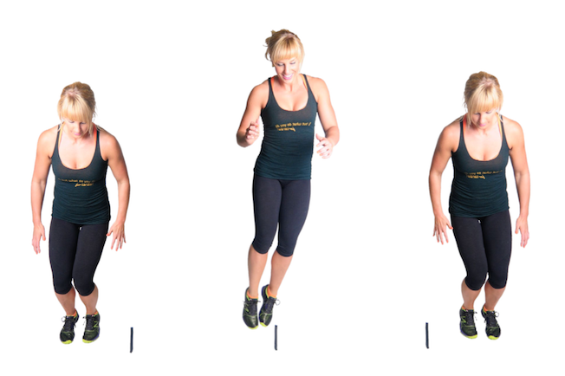

Make it easier – step over the lines rather than jump
Make it harder - instead of a line use a raised wedge. Must be able to collapse easily. E.g. a teddy, a small cushion, kitchen or toilet roll.

- Running Challenge
This can take place inside or out. Place a marker on the floor and then place a basket/bin/bucket around 10 big paces away. Have a pile of coins next to the marker. To start, pick up a coin and run and put it in the bucket. Run back and repeat. How many coins can you put in the bin in 20 seconds?
10 big paces

Make it easier – decrease the distance - 5 paces
Make it harder – Balance the coin on a part of your body. Do not use your hands!

My results
I will add new challenges every three weeks
You can do the personal challenges more than once a week, and just put in your top score.
 | How many can you do in 20 seconds?
Personal Challenges | 23/3 | 1/4 | 6/4 | 15/4 | 20/4 | 29/4 | 4/5 | 13/5 | 18/5
Throwing Challenge
Jumping Challenge
Running Challenge

Good luck everyone!

Further ideas
Here are a list of recommended links of videos which can be followed (all are free of charge);

Active Essex
Keep Essex Active YouTube Channel: https://www.activeessex.org/keep-essex-active-youtube/
A Monday to Sunday timetable of ‘classes’ live on their You Tube Channel covering 4 areas- Gentle exercise, High impact, Health and wellbeing and Active families.
Keep Essex Active from Home: https://www.activeessex.org/keep-essex-active/

Youth Sport Trust #StayHomeStaySafe
www.youthsportstrust.org/free-home-learning-resource-primary
Primary and Early years sections. Early years there are 4 resources. Primary there are 3 resource areas- 1) PE home learning (athletics, dance, games, gymnastics, health related exercise, inclusion, locomotion, outdoor and adventure) 2) 60 second challenges (x20 challenges) 3) Active learning- how to include English and Maths in physical activities

Sport England- Stay in work out initiative- Get active at home, Get active outdoors tabs for further links
https://www.sportengland.org/stayinworkout

Change4life Activities for Children
https://www.nhs.uk/change4life

Chance to Shine cricket
https://www.chancetoshine.org/staying-active-during-the-covid-19-outbreak?utm_source=Portal+Teachers&utm_campaign=5811d5dc45-EMAIL_CAMPAIGN_2020_04_24_03_37&utm_medium=email&utm_term=0_b4486fc5f7-5811d5dc45-138455733

Cosmic Kids Yoga – Youtube- Yoga and Mindfulness is the focus
https://www.youtube.com/results?search_query=cosmic+yoga+

Joe Wicks Kids Workouts – Youtube
HIIT (High Intensity Interval Training) sessions for children (5min videos can be done in a small space), Kids Workout – The Body Coach TV. Every morning at 9am the body coach will be hosting a live workout session for children on his YouTube Channel
https://www.youtube.com/results?search_query=joe+wicks+kids+workout

Imoves Activities https://imoves.com/

Go Noodle www.gonoodle.com Free to sign up for families and educators

BBC SuperMovers https://www.bbc.co.uk/teach/supermovers/super-movers-day/zbmnnrd

Cosmic Kids Yoga – Youtube https://www.youtube.com/results?search_query=cosmic+yoga+

Healthy Futures – http://eepurl.com/gVYzoD
You will receive a weekly food and activity log plus daily exercise videos to keep your children active! You just need to sign up as a parent
Sporting Challenges: NEW Everyday we will be uploading a daily sporting challenge that can be completed at home, we encourage everyone to get involved on the hashtag #HFhome

@GetSet4PE will be tweeting an active task each day that schools are closed

Imovement : To sign up, all you need to do is use the link join.theimovement.com its free to join just click on the link or follow on twitter @imovesactive The imovement is separate to their paid for imoves and will be 100% free.

