KS2 PE
MENU OF ACTIVITIES
- Pick one starter, one main and one desert each day to complete
- Can you try each dish on the menu by the end of the week?
- What is your favourite starter, main course and desert?
- Remember keep within the Government guidelines: keep active and stay safe!

Starters
Joe wicks daily workout 9am on YouTube
Exercise challenges from the Healthy Futures Active Monopoly (see page 2): Do one each of the 4 ‘train stations’
Oti Mabuse Dance class at 11-30 am on Facebook
Main Course
Active Monopoly- Active Monopoly- Do one activity from each colour
#stayActive on twitter –Adam Rowland – goal keeping/Alex Goldman 1st challenge
Youtube live #Gymnastics with Max Whitlock Tuesday/Fridays 3-30pm
Go for a jog with your dog or if you don’t have one, can you and your parents keep up the daily mile?
Desert
Play hop scotch
Go out daily on your bike or scooter
Skip for 30 seconds then 30 seconds rest x 3

ACTIVE MONOPOLY CHALLENGES
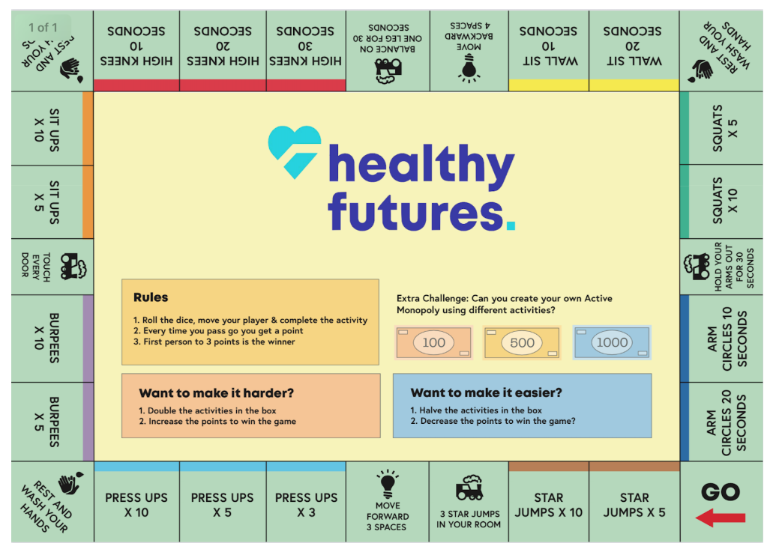

Further ideas
Here are a list of recommended links of videos which can be followed (all are free of charge);

Active Essex
Keep Essex Active YouTube Channel: https://www.activeessex.org/keep-essex-active-youtube/
A Monday to Sunday timetable of ‘classes’ live on their You Tube Channel covering 4 areas- Gentle exercise, High impact, Health and wellbeing and Active families.
Keep Essex Active from Home: https://www.activeessex.org/keep-essex-active/

Youth Sport Trust #StayHomeStaySafe
www.youthsportstrust.org/free-home-learning-resource-primary
Primary and Early years sections. Early years there are 4 resources. Primary there are 3 resource areas- 1) PE home learning (athletics, dance, games, gymnastics, health related exercise, inclusion, locomotion, outdoor and adventure) 2) 60 second challenges (x20 challenges) 3) Active learning- how to include English and Maths in physical activities

Sport England- Stay in work out initiative- Get active at home, Get active outdoors tabs for further links
https://www.sportengland.org/stayinworkout

Change4life Activities for Children
https://www.nhs.uk/change4life

Chance to Shine cricket
https://www.chancetoshine.org/staying-active-during-the-covid-19-outbreak?utm_source=Portal+Teachers&utm_campaign=5811d5dc45-EMAIL_CAMPAIGN_2020_04_24_03_37&utm_medium=email&utm_term=0_b4486fc5f7-5811d5dc45-138455733

Cosmic Kids Yoga – Youtube- Yoga and Mindfulness is the focus
https://www.youtube.com/results?search_query=cosmic+yoga+

Joe Wicks Kids Workouts – Youtube
HIIT (High Intensity Interval Training) sessions for children (5min videos can be done in a small space), Kids Workout – The Body Coach TV. Every morning at 9am the body coach will be hosting a live workout session for children on his YouTube Channel
https://www.youtube.com/results?search_query=joe+wicks+kids+workout

Imoves Activities https://imoves.com/

Go Noodle www.gonoodle.com Free to sign up for families and educators

BBC SuperMovers https://www.bbc.co.uk/teach/supermovers/super-movers-day/zbmnnrd

Cosmic Kids Yoga – Youtube https://www.youtube.com/results?search_query=cosmic+yoga+

Healthy Futures – http://eepurl.com/gVYzoD
You will receive a weekly food and activity log plus daily exercise videos to keep your children active! You just need to sign up as a parent
Sporting Challenges: NEW Everyday we will be uploading a daily sporting challenge that can be completed at home, we encourage everyone to get involved on the hashtag #HFhome

@GetSet4PE will be tweeting an active task each day that schools are closed

Imovement : To sign up, all you need to do is use the link join.theimovement.com its free to join just click on the link or follow on twitter @imovesactive The imovement is separate to their paid for imoves and will be 100% free.

